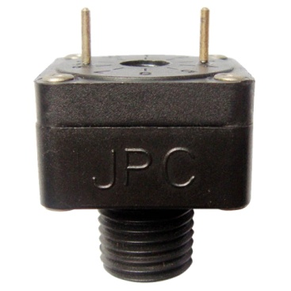

Type ZF

Slow action contact miniature vacuum switches for printed circuit boards with 5 mm pitch, plastic fitting. SPNO contact.

Uses: Low voltage, high sensivity.

Main applications: Electronic printed circuit.

Fluid: air or water.

Pressure: negative (Vacuum).

Housing: PA66, UL94 VO.

Contact: single pole normally open at atmospheric pressure, slow make.

Electrical rating:

- Silver contact: max 1A 250V.

- Gold plated contact: max 100 mA, 24V.

Action: momentary, close on vacuum increase.

Set point calibration limits (relative pressure): standard calibration minus 50mbar, other values are achievable from minus 20 to minus 200 mbar.